

National College of Ireland

Project Proposal

Farmers Market

An E-Commerce Web Application for trading fresh local products

Date: 3rd of November 2020

BSc (Honours) in Computing

Software Development

Academic Year 2020/2021

Student Name: Daniel Costel Neagu

Student Number: x17128463

Student Email: x17124863@student.ncirl.ie

**Contents**

1.0 Objectives 2

2.0 Background 2

3.0 Technical Approach 3

4.0 Special Resources Required 4

5.0 Project Plan 4

6.0 Gantt Chart 5

7.0 Technical Details 6

8.0 Evaluation 7

9.0 References 7

# Objectives

For my final year project, I have chosen to build an E-Commerce Web Application that it will allow trading Online and in a new market.

By creating this project, I am going to develop an E-Commerce Web Application that is going to facilitate the Online trade of local source goods and products, just like a Farmers Market used to do. This project objective is to get the local community reconnected with their local Farmers and Producers by providing them with an alternative to this disrupted market by the current Global Pandemic.

The most challenging part of this E-commerce Web Application is to make it work successfully, other than the technical implementation and learning of different interconnected systems and technologies from my side, it will be to move the classical approach view of a Farmers Market as a brick and mortar place of commerce and bring it to an Online E-Commerce Platform where the customers and farmers come together and do business.

This E-commerce Web Application is specially built to help the local Farmers and Producers, that are the most affected by these strange times that we all are living in, by providing them with this new Platform, where they can advertise and sale their products.

It will benefit the local community as well, were the local people can purchase again their favourite fresh products as they did once from the Farmers Markets, but this time, safely within reach of a click on the Application and within the Government guidance of respecting Social Distancing Measures.

# Background

As we are aware of the current Global Pandemic caused by the virus SARS Covid.19 and the effects that it can have on all of us, the Governments of all the Country’s in the World, are trying to reduce the number of people getting sick by this virus.

In Ireland sadly, almost every month the authorities are taking more and more actions on restricting peoples movements In and out of their County, City or even limiting the distance on how far the citizens can travel outside their homes, leaving areas of the city where people used to go and shop at their local Farmers Market unreachable to most of them.

As I looked at my current living situation, I soon realized that by recently moving in a different house, it’s going to be a bit difficult for me now to access some areas of the city that I was fun of them before. The main cause of this matter is the result of new future restrictions to come in the nearest future from the authorities that are put in place to help to stop spreading the Virus Covid_19.

One of these places was my local Farmers Market with my favourite artisan food, cheeses, meats, organic vegetable and fruits. As I wanted to be able to continue to enjoy having them even when the restrictions will restart again to be stricter, I began looking online to see from where I can purchase them from an E-Commerce Website and having them delivered to my new address straight from the Farmers Market. The result of my search revealed that at the moment it is a major gap in the market with the presence of an E-Commerce Farmers Markets Platform, as no Website was available to trade with any products.

By not being able to find any source online from where I can purchase them, I soon realized that this a great opportunity for me to create an E-Commerce Web Application where I can bring together the local Farmers, Producers and Customers. This trade can be extended to other nationwide local Farmers Markets, serving each area in the state and allowing them to trade on my platform.

# Technical Approach

At first, before I start working on building my application, I must understand how all is going to function in the big picture. One of the very first steps taken in this direction, I will start documenting the requirements specifications for the project. As part of my research in this area of gathering the requirements for my project, I will have to go back on my notes from previous semesters on Business Analysis module and I have to reed over BABOK guide for a quip refresher.

Another step that is taken, it will be by building a Mockup sketch by designing a low fidelity wireframe using the Balsamiq tool for better visualisation of the application that I want to build. In this way, if I noticed anything out of place in the prototype, I can modify the design and find the best solution for the UI.

The actual work of developing the application can start at this stage after gathering the requirements and designing the prototype. All the coding part is going to be done on Visual Studio text editor and all the libraries used for the project are going to install in there.

The deployment will be the next step in my project and for the moment I didn’t decide whom to choose as a hosting services provider.

# Special Resources Required

One of my special requirements for my project it will be to buy the domain name for Farmers Market.ie and then depending on the packages received on the purchase I will be able to choose the Cloud provider for the application. One of them to consider it will be Heroku, as I must take into consideration the database type that they support on their platform.

# Project Plan

The Project Plan in Figure 1 from the page below is created by using Microsoft Excel and after watching the recommended YouTube tutorial hosted by Dr Eugene O'Loughlin, Lecturer in Computing at National College of Ireland (2013). The objectives of the project are represented in the Task column with its dedicated duration time for completion, calculate in days. A Status is appointed to each task according to the activity performed on it at the moment.

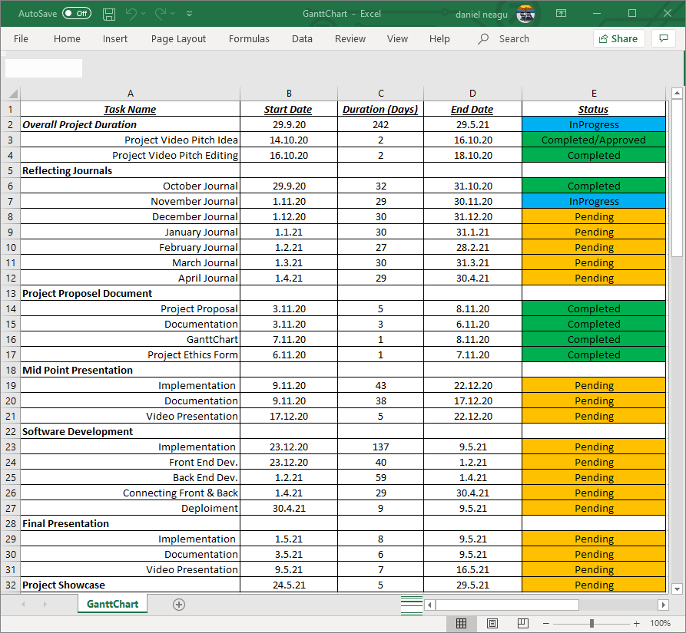

Figure 1 (Project plan)

# 6.0 Gantt Chart

The Gantt chart is incorporating the specific tasks and they are represented on the horizontal bar and the date on the top bar indicating how long the specific tasks are supposed to last.

For a better visual representation of my project timeline, reflecting the project plan is shown below in Figure 2 or you may click on the attached Excel folder here:



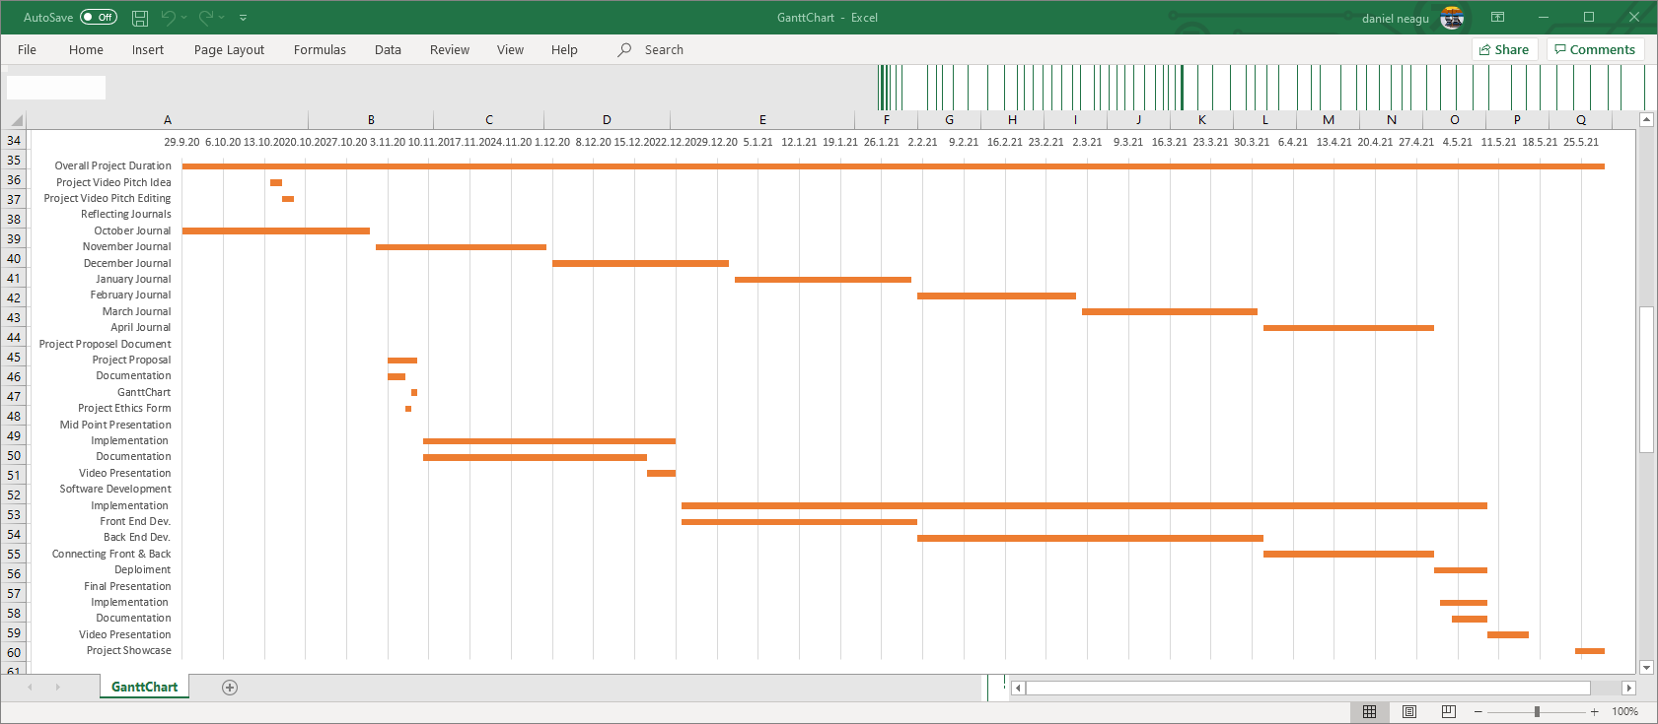

Figure 2 (Gantt chart)

# 7.0 Technical Details

To choose the right tools to build a fully functional E-commerce Web Application and to be deployed successfully is going to be quite some challenge. I am more than sure that some changes to the technologies chosen by me, may occur from the moment I am writing this document up to the finish.

To make it simple for me I will split this project into three deliverable categories. I will implement a well-defined structure with dates to keep Trak of my progression, all these deliverables can be viewed in the Software Development Tasks described in section 5.0 of the Project Plan.

The first part of the project is to build the Front End of the Website, using a common coding language like Hypertext Markup Language (H.T.M.L.) to help me to display the Website that I will design and to be displayed on any web browser chosen by the viewer. Cascading Style Sheets (C.S.S.) to give a little bit of styling on how the web page is going to be displayed on various devices and screens sizes. I will use a scripting language too, like JavaScript (J.S.) and Node.js to help me to add some interactivity to my web site. One of the libraries that I will use in this project is React, it will be used to render dynamic components defined in JSON.

For the second part of this project, I will use Node.js on the server-side or the back end of the build, is to help me to produce a dynamic website. For stock management and any other general-purpose data that needs to be captured and stored I will use MongoDB, because is used for modern applications (MongoDB, 2020), is built for the Cloud and I can use JSON to create and interact with it.

And the third part of the project I will be the connection the front end with the back end of the application and deployment. For these two actions, I have to look for more details later on, because I will be constrained by the Cloud provider and I will have to choose the options available at the time of deployment.

# Evaluation

Considering the environment and the unfamiliar times that we live in, evaluation of the system has to be done by myself as I didn’t manage to secure any contacts to build this project. I will use mock-up data to populate the necessary field, at a list in this way I will test my database and I will create some fictive profiles for suppliers and customers side, at least in this way I will make a proof of concept that my application is up and running with no problems.

# References

MongoDB (2020) *The database for modern applications* [Online] Available at: <https://www.mongodb.com/> [Accessed 3 November 2020]

Eugene O'Loughlin (2013) *How To... Create a Basic Gantt Chart in Excel 2013* [Online] Available at: <https://www.youtube.com/watch?v=QdsjVN3du78>, [Accessed 3 November 2020]